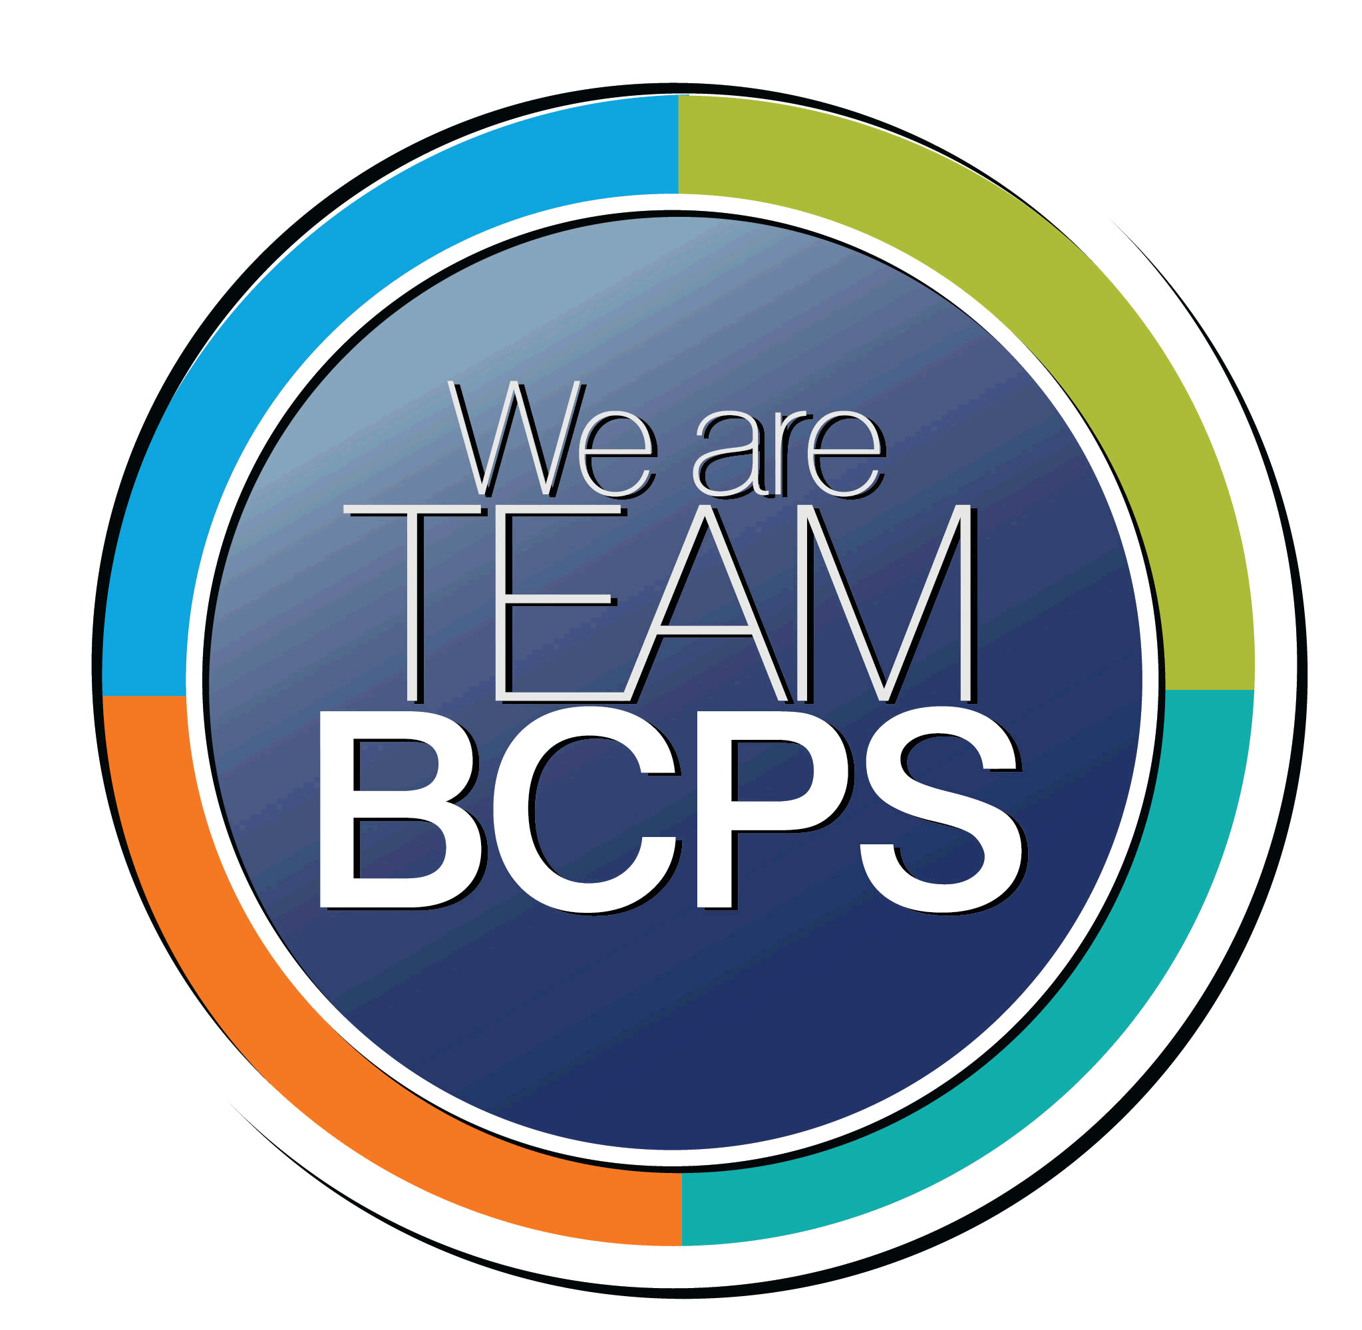 **Schoolwide Positive Behavior Plan** 

**Baltimore County Public Schools**

**Date Completed: 8/13/2021 School Year 2021-2022**

**School: Gunpowder Elementary**

|  |
| --- |
| **Section 1: Initial Steps** |
|  |
| **School Climate Team** |
| *Identify members of a School Climate Team (consider a representative selection of members). The team meets initially to examine equity concerns and data and to develop the Schoolwide Positive Behavior Plan. The team should then meet monthly (minimum quarterly) to assess the effectiveness of the SWPBP on an ongoing basis.* |
| School Climate Team will meet monthly  School Climate Team Members: Kristen O’Neill, School Climate Guide and Safe Keeper Consultant, Brianna Sosnowski, Special Educator and Safe Keeper Consultant, Patricia Kuebel, Special Educator and Safe Keeper Consultant, Heather Insley, Assistant Principal, Wendy Cunningham, Principal |
| **Equity Lens** |
| *Through an equity lens, identify what the data indicate about the social-emotional needs of students and the support provided by staff members relative to disproportionality between student groups, especially for African Americans or students receiving special education. Also consider the school’s population with regard to ELL, Latinx, and/or other student groups. (Information may be from School Data Story)* |
| The 2018 – 2019 suspension rate was 0%, a decrease from 2017 – 2018. Students receiving special education services were suspended at 34 times the rate of their peers. For the 2018 – 2019 school year, all student group suspensions resulted in the loss of 0 instructional days.  The 2018 – 2019 Stakeholder Survey domain values were 84.7 for Academic Aspirations, 73.2 for Belonging, and 76.6 for Student Support.  The 2018 – 2019 Belonging domain results indicate the more favorable for the Asian student group. In contrast, the Two or More Races student group reported the highest as unfavorable among racial groups.  The 2018 – 2019 Student Support domain results indicate the most favorable results for Two or More Races student group. In contrast, the Black/African American student group reports the highest as unfavorable among racial groups.  As indicated in the School Data Story, the following student groups are the most underserved: Black/African American, Two or More Races, Special Education, English Learners. |
| **Data Analysis** |
| *Summarize what the data tell about the school climate. (Information from School Data Story)* |
| 2020 – 2021 Referrals   |  |  |  |  |  |  |  |  |  | | --- | --- | --- | --- | --- | --- | --- | --- | --- | | Total School | | | | | | | | | | 8 Students | 1 Black | 1 IEP | 2 504 | 3 SST | 2 |  |  | 35 Total Referrals |   Relevant baseline data collected in Quarter 1 of 2020 – 2021 School Year |
| **Climate Goals** |
| *Identify the school’s goals in improving the social-emotional climate of the building. (Information from School Progress Plan)* |
| Educators will call upon the inner Powers of Perception and Acceptance, along with corresponding skills of composure and empathy (*Conscious Discipline: Building Resilient Classrooms* by Dr. Becky Bailey) to manage upset, solve problems, and build/repair healthy relationships. This internal reflective work will serve as the foundation needed to develop a conscious understanding of the unique challenges and barriers faced by individual students, families, administrators, teachers, and staff to provide additional supports designed to help overcome these obstacles.  Goal: To build capacity within educators to empower themselves and their students to cultivate inclusivity within our Gunpowder family, through the alignment of our words and actions with our Gunpowder Family Inclusivity Compass. The result will be ALL members of our school family feeling physically and emotionally safe, loved and able to learn at accelerated levels. |
| **Section 2: Developing and Teaching Expectations** |
|  |
| **Expectations Defined** |
| *Identify a School Code of Conduct with 3-5 positively stated school expectations. Develop a way to communicate the identified rules, based on the schoolwide expectations, for specific settings within the school building. Expectations should be clearly stated, communicated, taught, and frequently referenced.* |
| Our Gunpowder Family mission: Free to be you, Free to be me, Free to use our agency, We are Gunpowder Family.  Our Gunpowder Family Inclusivity Compass will be explicitly taught and referenced, as we engage ALL members of our school family in SEL lessons, Class Family Meetings, Safe Keeper Consultation sessions, Behavior Handbook Lessons, and conflict resolution sessions.  All students and staff engage in “Safe Keeper Talks” with our administration based on The BCPS Handbook and visual entitled: Gunpowder Elementary Freedom Cruise Rights & Responsibilities. These include:  **Rights:**  Safe Learning Environment  Acceptance  Personal Property  Technology for Learning  Make Mistakes and Learn from them  Express My Feelings without Hurting Others  **Responsibilities:**  Attend School Daily  Engage in the Learning Process  Honor Other Family Members’ Dignity  Follow the Technology Acceptable Use Policy  Be Polite/Use Appropriate Language (writing/speaking)  Demonstrate Safe Treatment of Others  Protect School Property  Only Bring Items that are Helpful to Our Safe Learning Environment  Demonstrate Positive Behavior  Accept Responsibility for My Actions/Words  Practice Virtues  In addition, students will revisit the *5 Steps of Self-Regulation* and the *7 Powers of Conscious* *People*. A near point copy of the visuals are provided to all students. |
| **Classroom Plan for Teaching and Reinforcing Expectations, Routines, and Procedures** |
| *Teachers develop visuals to communicate culturally relevant classroom expectations, routines, and procedures based upon the schoolwide expectations. Educators explicitly teach expectations, routines, and procedures. The school staff recognize and reinforce expected and positive behavior. Teachers identify encouraging procedures and corrective procedures for their classrooms.* |
| All educators are expected to include in their classrooms/learning spaces visuals with calming strategies, self-regulation steps, and a safe place for students to gain their composure when feelings cause them to exhibit behaviors that are perceived as unsafe or hurtful. All classroom teachers are expected to teach ALL grade level lessons created by BCPS to teach Conscious Discipline strategies, using text that is culturally relevant, along with the Shubert books. All classrooms (Cruise Cabins) will have posted anchor charts with expectations for routines and procedures to be revisited regularly. All students will engage in mini-lessons focused on Virtues during Class Family meetings, create commitments, and reflect on progress toward meeting these commitments at the conclusion of each day. As part of opening procedures for each class family, teachers will lead students in a Safe Keeper Ritual (including special area teachers) and use noticing/acknowledging language to build within our students and educators the confidence that all will be well.  Virtue and noticing language keychains are provided to staff and families, along with support personnel to consult with when the educator is unsure of how to proceed in a challenging situation, specifically the language to choose to remain conscious, responsive and to set limit while providing choices.  ***Resources available in Schoology folder:***  *Class Family Meeting resources*  *Visuals for expectations for active listening and respectful talk*  *Help cards*  *Every student response cards to increase engagement*  *Conscious Discipline Feelings and Self-Regulation resources*  *Songs to support connection and the virtue of unity*  *Expectations for small groups and independent work time* |
| **Family/Community Engagement** |
| *Identify how the Schoolwide Positive Behavior Plan, the schoolwide expectations, and/or interventions will be communicated and shared with families. Consider how to include family and student voice in the initial plan and in evaluating the plan throughout the year.* |
| Our Gunpowder Family Safe Keeper resources and expectations will be shared with families during Back to School Open House, by teachers during their Back to School virtual presentations, and through resources provided in school communication folder. In addition, resources and guidance will be provided to families during support team and IEP team meetings.  The Climate Team will identify options to obtain student and parent/guardian voice regarding the Schoolwide Positive Behavior Plan, various perspectives, and considerations for the continual revision of school wide expectations and practices being utilized to maintain a safe, loving and inclusive school family.  Our Gunpowder Family customized student planner will be used to develop within our students in grades 1-5 the self-regulation skills of planning, work completion, and self-monitoring of completed assignments. The planner also includes resources for students and their families to support academic and social emotional skill development and acceleration. |
| **Section 3: Developing Interventions and Supporting Students** |
|  |
| **Resource Mapping of MTSS** |
| *Identify the evidence-based practices and interventions offered at Tier 1, Tier 2, and Tier 3 to support all students. Consider what culturally responsive interventions the school requires to meet the specific needs of the students.* |
| **Tier 1 is the Universal Prevention level, which is provided to all students. Tier 1 includes core instruction and evidence – based practices that are applied consistently and systematically across the school population.**  ALL students at Gunpowder Elementary have access to the following evidence – based practices and interventions: School Code of Conduct (Freedom Cruise Right and Responsibilities), Class Meetings, Brain Smart Start, Virtue Instruction/Character Education lessons, Noticing Language, School Counseling Lessons based on BCPS Counseling Curriculum, Conscious Discipline Feeling Buddies, Safe Place to regain composure, Time Machine to resolve conflict and practice assertiveness, parent/teacher conferences, Peer Mediation, responsive individual or small group counseling session with school counselor.  **Tier 2 is the Targeted Group or Early Intervention level which is provided to selected students based upon an identified need. These students may need supplemental instruction or intervention, in addition to core instruction/universal prevention in order to meet identified outcomes.**  Gunpowder Elementary Tier 2 interventions include the following: Small Group Social Skills Instruction, Check – In/Check – Out, Individualized Safe Place, Individualized Visuals, Small Group counseling sessions with School Counselor, referral to individual counseling (in partnership with Balance Point Wellness), Logical Consequence Visual Supports, Root Cause Analysis, Parent/teacher conference with administrator or support staff, Student Support Team meetings, Student Support Plans, with monitoring.  **Tier 3 is the Individual and Intensive level which is provided to a small group of students who have significant needs that require intensive intervention in addition to core instruction/universal prevention.**  Gunpowder Elementary Tier 3 interventions (parent permission required) include the following: IEP team, FBA/BIP development and implementation, Crisis Response Team Intervention, access to Gunpowder Family Safe Place. |
| **Social-Emotional Learning** |
| *Identify the specific evidence-based social-emotional learning skill development practices the school will implement during the school year. Consider the importance of trauma-informed care, mental health awareness, level of students’ coping skills, etc. Determine how the social-emotional learning and the SEL competencies will be integrated into the school’s programming. Consider the need for any training the staff members may require.* |
| Gunpower Elementary School educators prioritize social-emotional learning and believe that students and adults must feel safe and loved to learn. Our school family implements daily Conscious Discipline practices including Brain Smart Start, Greetings in ALL classrooms, including special area and resource rooms, Safe Places, Noticing Language, Classroom jobs, Safe Keeper Rituals, “Helpful, not hurtful” reminders, Wish You Well, and SEL/Virtues mini-lessons in order to cultivate a safe, inclusive, and loving learning environment for ALL students and adults.  During the 2021-22 school year, Gunpowder Family educators will continue deepening our understanding of disciplining consciously, pausing to maintain our composure, so that our response is intentional, non-judgmental and increases our resiliency and the resiliency of our students. Gunpowder Elementary has been selected as a BCPS Conscious Discipline Focus School for the 2021-2022 school year.  With training provided by BCPS, our educators will continue deepening our understanding of neuroscience, self-awareness of our perceptions, and self-regulation. |
| **Character Education** |
| *Determine how specific evidence-based character education learning will be infused into the school’s programming to promote positive behavior and ethical decision-making. Character education will be culturally responsive and co-created with diverse stakeholders. Consider the need for any training the staff members may require.* |
| Our Gunpowder Family strives each day to become more virtuous and conscious. Gunpowder has been implementing and will continue to implement the Virtues Project. Two virtues are identified per month with school/family activities that are sent home. These virtues are also highlighted as part of Brain Smart Start. Adults acknowledge children and adults who are demonstrating virtues, using noticing language and citing specific examples to increase self - love, self - confidence, and self - discipline. For example, “Thank you for demonstrating self-discipline as you worked quietly during the unit test. That was helpful to our school family.”  Our Gunpowder Family participates in school-wide, county, and state activities/celebrations intended to highlight positive personal choices, safety and wellness. These include Kindness Week, Bullying Prevention Week, Pinwheels for Peace, Red Nose Day, Red Ribbon Week, Children’s Mental Health Matters, and Unity Day. |
| **Professional Development for Staff** |
| *Identify the professional development that will be offered to staff members throughout the year in order to support their knowledge, skill development, and implementation of the interventions selected, the character education learning, and social-emotional learning practices. Specify the schedule for professional development and how to obtain teacher feedback during the year to address their concerns and areas in which they want/need more information. (Information from School Progress Plan.)* |
| Professional Learning Opportunities to support a safe, loving, and inclusive school family include:  Conscious Discipline Strategies, Routines, and Rituals:   * Brain States * Brain Smart Start * Noticing Language * Setting Limits (Helpful/Hurtful) * Five Steps for Self – Regulation * Virtues Language, Virtues Cards, Virtues Educator Guide * Logical Consequence Charts * Openness and resiliency   BCPS Conscious Discipline Focus School Support and Professional Learning:  +Building Resilient Schools and Homes e-course through Conscious Discipline for school administrators and Climate Team.  +2-hour webinar to support both building awareness and school-wide implementation of Conscious Discipline.  +Powers of Resilience e-course.  +Vicky Hepler, Master Instructor, monthly coaching sessions this year.  Safekeeper Consultation Documentation Forms:   * Educators will utilize the Safekeeper Consultation process and Documentation Form to empower ourselves to be safekeepers of our classrooms and the children within. * Educators will reflect upon effectiveness of the process and impact on connections established with challenging and/or “difficult to connect with” children who struggle to maintain composure and exhibit hurtful behaviors at times. * Educators will engage in internal reflection and courageous conversations focused on conditions we create for students, our capacity to respond consciously, and to ask questions to better understand how to best support all children in our school family.   Agency Lessons & Sentence Starters:   * Educators and students will engage in lessons aimed at deepening our understanding of agency and how agency increases achievement and success. * Educators will learn how to provide choice and offer opportunities for students to “use their agency” that is age-appropriate and maintain a safe and predictable classroom for ALL.   Walkie Talkie Communication Procedures   * Educators will communicate on 2-way radios so that the dignity of each human being within our school community is maintained/protected. * Educators will be provided with resource with protocols for communication, including examples of correspondence. |
| **Section 4: Supporting and Responding to Student Behavior** |
|  |
| **Recognitions/Incentives** |
| *Identify a variety of positive consequences, acknowledgements, recognitions, and/or incentives that are linked to the behavioral expectations and rules. Develop a system for implementing the positive acknowledgements consistently in school settings. Consider how to monitor who is being recognized and who is not being recognized and whether explicit or implicit biases may be occurring.* |
| Our Gunpowder Family’s mission states, “awakening the joy within each person and developing into our authentic selves.” For this to occur, we believe that students need conscious, predictable and loving adults to communicate clearly and succinctly. As a result, it is our family practice to acknowledge each other using noticing/acknowledging language, virtues, and evidence to support affirmations. For example, “Way to go! You did it! You learned all your level 2 sight words. That took perseverance and determination to practice your words each night. Ring the bell!”  Students are encouraged to use this language with each other, sharing what they have noticed during class family meetings or during lesson closure. This aligns with our vision of a safe and supported school family that practices the virtue of unity. |
| **Hierarchy for Behavioral Referrals and Consequences** |
| *Identify the behaviors that are teacher-managed, behaviors referred to resource staff, and behaviors referred to administration. Refer to the BCPS Student Handbook for teacher and administrator-led interventions. Consider how unsafe behaviors will be addressed.* |
| Gunpowder Family responses to unsafe/hurtful behavior are unique to each student, while honoring and following expectations/consequences identified in the BCPS Student Handbook.  Teacher Managed: Unsafe/hurtful behaviors manifested from feelings not able to be regulated, student conflict, not including threats or physical attack.  Examples: following directions, keeping hands & feet to myself, quiet voice, walking feet, using kind words, gentle touch  Resource Staff Managed: Logical Consequence Chart implementation requiring support staff to implement, Class Family Safekeeper Request for Consultation, response identified in a student’s BIP or IEP.  Administrator Managed: Threat to self or others, physical harm/attack, possession of item that is harmful/hurtful resulting in teacher/students feeling/being unsafe. |
| **Response for Intensive Behaviors** |
| *Identify a hierarchy of responses to intensive behaviors (i.e., emergency/crisis management/threat assessment/unsafe behaviors) including interventions and supports. Indicate which school staff members will respond as well as procedures and training as needed.* |
| **Response to Classroom – Managed Behaviors**  Teacher/Safekeeper Support Provided  *Detachment – This is not happening to me, but in front of me.*  Did I:   * 1. Use noticing language (I notice your _____, what do you need?) * 2. Set limits with choices in a calm, predictable voice and using a visual support   + Helpful/hurtful language * 3. Coach & work through the 5 steps of self-regulation (Using card)   + Safe Place   + Breathing   + Feeling Buddies   + Strategy   + Solve * **4. Call for Consult** - The student is still experiencing difficulty with self - regulation and/or is displaying unsafe behaviors (I need support in Room ___)   + Using Gunpowder Family Safekeeper Documentation Form give consulting team member quick overview of student’s behavior. *Ensure that conversation is out of area in which other students can hear.*   + Using teacher choice board, choose next step/action to maintain student teacher/connection   **Response to Intensive Behaviors:** BCPS Student Handbook procedures will be followed by administrators. Consultation will occur with Emergency Manager when situation necessitates to ensure a safe school environment for our Gunpowder Family.   * Request for administrator will be made for threats, attacks or fighting, possession of something that is allowed in the school environment. * Removal from Classroom is considered when unsafe behaviors occur (throwing, kicking, hitting, spitting, hurting self or others) or if child is found to have something at school that is against the rules and regulations as stated in the BCPS Student Handbook. * If the student is throwing or ripping items in the classroom, the class family may be removed and the distraught child would be monitored/supported by a support staff member and/or administrator.     **Example of Logical Consequence Steps** **Visual** for harmful or unsafe behavior:   * 1. Report to School Safe Place * 2. Have a calm body & quiet lips for 5 minutes * 3. Read Shubert Book/Utilize Feeling Buddies * 4. Restore Relationships/Repair Harm * 5. Complete Work * 6. Return to Class Family   **School Staff Members Responding:**  Special Educators, School Counselor, Assistant Principal, School Psychologist, Principal  **Procedures and Training for ALL school staff:**   1. Safe Schools Training – FBA – Specifically Section 2, Challenging Behavior: Assumptions and Functions. 2. Video Models & Small Group Discussions for utilizing teacher choice boards 3. Time Machine- Conflict Resolution Mat 4. Visual Reminders for Individual Students with Expected Behaviors 5. Shubert Rule Cards |
| **Monitoring the Schoolwide Positive Behavior Plan/Data Analysis** |
| *Identify the data that will be collected and reviewed by the School Climate Team in order to identify behavior trends, patterns, action steps, and interventions using a problem-solving strategy. Consider having a uniform referral form for staff to complete to document referrals to administration. Consider how teachers should document classroom-managed concerns/behaviors/difficulties. (Information from School Progress Plan.)* |
| Gunpowder Family Safekeeper Consultation Documentation Forms will be analyzed to determine behavior trends and patterns. Forms will be analyzed to determine if teachers are able to assist students through steps of self – regulation and help them return to the executive brain state, or if additional support from the support staff continues to be required at the same rate. |
| **Section 5: Miscellaneous Content/Components** |
| **Click or tap here to enter text.** |